August 1, 2008, 3:17pm

Still in Diapers  Posts: 27
  Okay. First of all you have the system wrong. Here it is from Mike Caro.
  I'm going to give you a secret roulette system that really works. It will cut the house advantage to literally nothing, if you believe in it enough to never get frustrated and switch tactics. What I'm going to say may seem strange, but here goes.
  First, never bet simply red or black. Also don't bet odd or even. These are equally poor, consistently losing wagers.
  Second, don't be suckered into betting zero or double zero, despite what some experts may suggest. This may seem like you're betting with the house, but for technical reasons you are actually betting against the house -- and you are taking the worst of it.
  So, in order to negate the house advantage, you MUST stick to straight non-green number bets. All odd red numbers turn out to be bad choices, based on over two trillion computer trials. Don't bet them.
  All even black numbers fair poorly, and cannot be bet, for much the same reason, which I won't explain here.
  Let's get straight to the money-saving advice. Any bet you decide to make MUST cover only even-red or odd-black numbers. There are no exceptions.
  Finally, you need to be very disciplined in excluding the number 30 and the group of consecutive numbers that begins with 11 and continues clockwise through and including 14.
  This system may seem mystical, but I take gambling quite seriously, and this works for me.
  END ORIGINAL POST
  Straight Flushes,
  Mike Caro
  Here is a screen shot from a program I'm currently writing.
  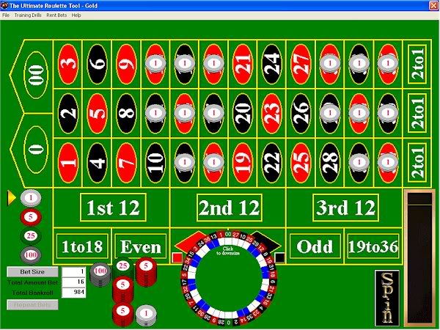
  This graphic shows what numbers are covered when you bet all odd blacks and all even reds.
  Now here is the catch. You stated that you don't bet the 11,12,13,14,and the 20.
  It should actually be that you don't bet the 30 (instead of the 20) and starting with the 11 on the wheel, you go clockwise eliminating every bet until you get to the 14, and you include the 14. What do you have left?
  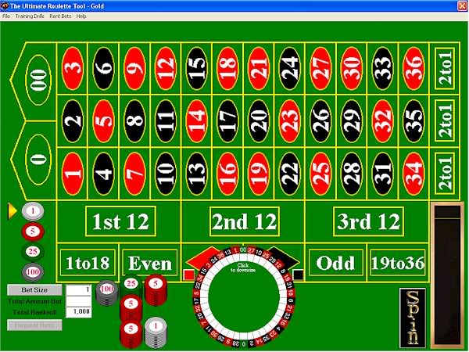
  You have no bets on the layout left.
  Here is Mike Caro's response to the original system:
  Caro Roulette System #1
  By Mike Caro, "America's Mad Genius"
  "Why my system really works!"
  Leading experts agree: Caro's Roulette System #1 really does cut the house advantage to literally zero -- Here's why in the creator's own words
  OK, since you were smart enough to come to this page, I won't play any more games with your mind. Here's the truth.
  People are always asking me for good roulette systems. This disturbs me, because for many years I have preached that there are some gambling games you can beat and some you can't. In the can-beat category are poker, sports wagering, blackjack, and more. In the can't-beat category are craps, roulette, wheel of fortune, keno, and much more.
  Yes, I will entertain arguments that you can theoretically beat roulette by measuring the rotation of the ball and the speed of the wheel. But that's another matter for another day -- and, besides, this turns out to be better in theory than it is in practice.
  So, let's look at Caro's Roulette System #1. In saying that my system could cut the house edge to literally zero, I chose the word "literally" quite carefully. It means that "zero" is to be taken precisely to mean "zero." If you follow the instructions exactly, all bets are eliminated. You can sit and watch the wheel spin forever, but you will never make a bet -- unless you violate the instructions.

