Summary of the Great Universal Theory:
GUT is a bet selection strategy that focuses on binomial distribution.
Note the following certainties in a session of roulette.
- There will be a number of Unhit numbers ranging from 0-37
- There will be a number of numbers hit a specific amount of times at all times ranging from 0-37
- All Numbers will be hit at some point regarding infinity
If we represent these certainties on a graph we'll see that the amount of numbers that remain unhit will start at 37 (obviously there are no numbers hit when you start a session). After the first spin, 1 number will be hit ONCE and 36 numbers will remain unhit.
Over the course of several spins, the amount of numbers that remain unhit will eventually drop to 0.
The amount of numbers that have been hit ONCE and only once will raise as numbers are hit for the first time and then drop to 0 as numbers are eventual getting hit for the second time.
This is also true for numbers that have been hit TWICE and more...

Numbers hit more than once, more than twice etc. are also each represented by a curve on the graph. These will start at 0 and over the course of several spins, these properties will raise to 37.

What we have now is something similar to the graph below:

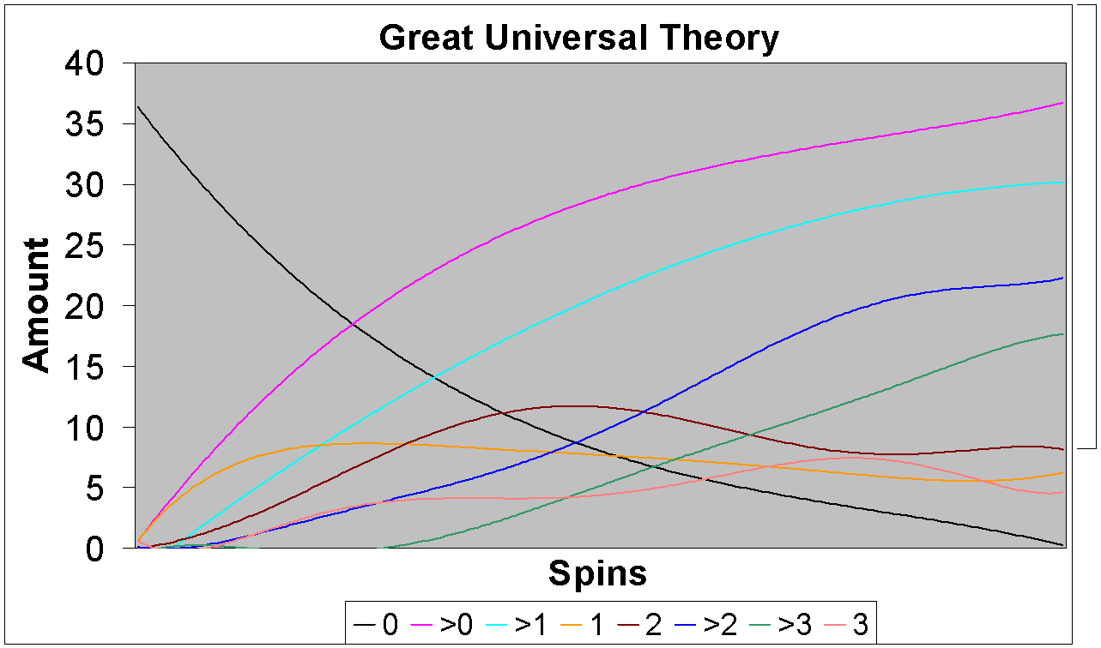

The above graph is from a real session and the graph below is the theoretically balanced distribution.:

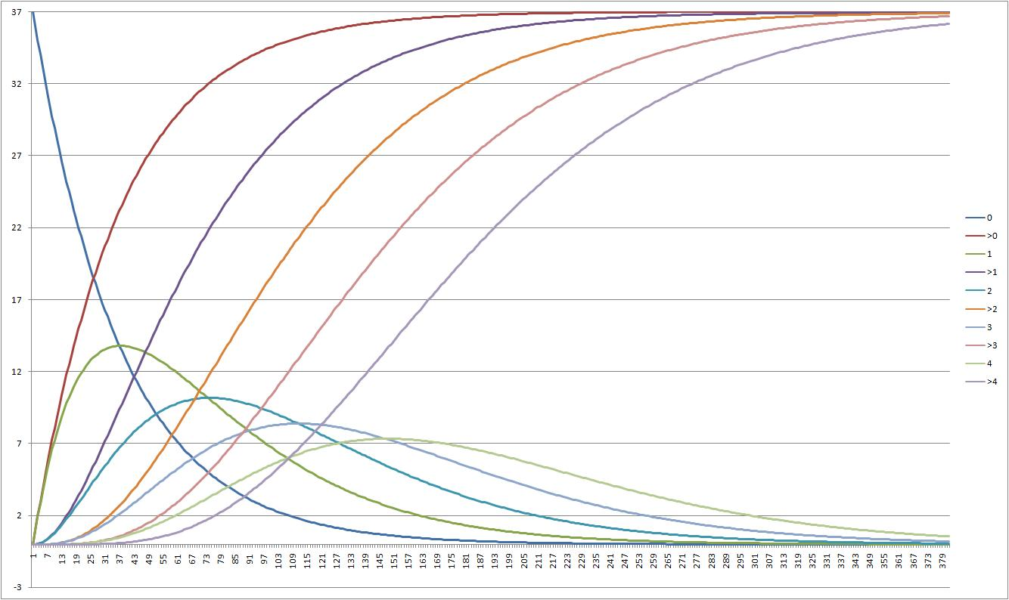

What do all these lines mean then?

On the first graph only:
The black line represents the amount of numbers currently NOT hit at every spin.
The pink line represents all the numbers hit ONCE or MORE.

First... Let's just focus on these, the other lines each represents "Numbers with status hit exactly once" at every spin... Those that are hit exactly twice... twice or more, exactly 3 times e.t.c...

You don't need to bother about those now, just focus on the black and the pink one.

Are there some certainties about these that we remember from before?
Yes. The black line representing all numbers with the status unhit after every spin, will go from 37 numbers before the first spin to 0 numbers after the course of some spins.
The other line, representing numbers with the status hit once or more after every spin, will do the opposite, go from 0 to 37 numbers hit.

What can we conclude from these certainties?
Well, the thing that you take advantage of with GUT is that these lines HAVE to cross at some point. This can only happen when the amount of unhit numbers are 1 more than the amount of numbers hit.
This narrows our opportunity to bet on the unhit numbers. We call this a crosspoint
Generally, this specific crosspoint is not worth betting on.

If you now look at the other lines, it doesn't matter what kind of status they represent, you will see that they are all crossing at least one other line. These crosspoints are other betting opportunities.
The rules are as follows:

We have 37 numbers on the wheel, after the first spin we have had 1 appear and 36 have not appeared (that’s logical enough) with the second spin we count again.
If you proceed with this counting you will eventually get a situation where you have19 numbers that haven't appeared yet, and 18 numbers that have appeared once or more.

This is the first possible "crossing", but it is not recommended that it be played.

All possible crossing that can be played:
18-17
17-17
17-16
16-16
16-15
...
etc...
...
2-1
1-1
1-0

We have these crossings between
0 and 1 (numbers that have not hit and numbers hit once)
0 and >0 (numbers that didn’t appear and numbers that appeared) once and more than once
1 and >1 numbers appeared once and numbers appeared more than once
2 and >2 numbers appeared twice and numbers appeared more than twice.

We bet when a crossing is in sight.

A crossing is in sight, when the difference between two characteristics is 0 or 1 (see list above).

Betting:
17-13 numbers rebet after loss = total bets 2
12-10 numbers rebet after loss 2 times = total bets 3
9-8 numbers rebet after loss 3 times = total bets 4

36/numbers=times to bet (use first number only; 3,5 = 3)

Stop at >39 units otherwise play till spin 50, no stoploss no limit

Rebet a crossing as long as it is alive
15-14 moves to 15-13 stop betting
15-14 stays 15-14 rebet (once see above)
especially later in the spins when bet 0vs2 appear:
9-9 loss
9-9 loss
9-9 loss
9-8 loss stop betting

9-9 loss
9-8 loss
9-7 stop (crossing no longer showing)
9-8 (a 1 has hit) start betting max 4 times again

Play
0vs1
1vs2
0vs1>
0vs2>
1vs1>
1vs2

