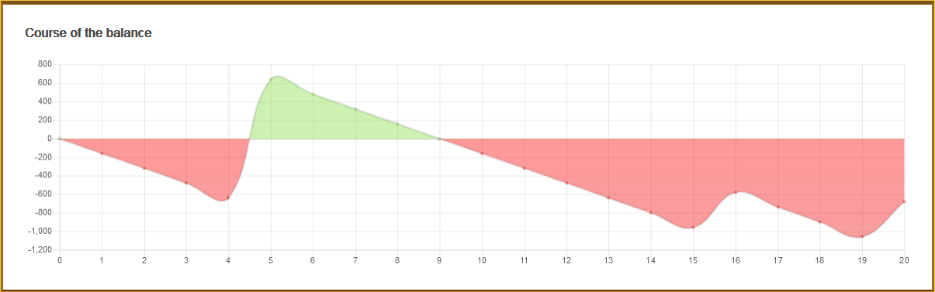
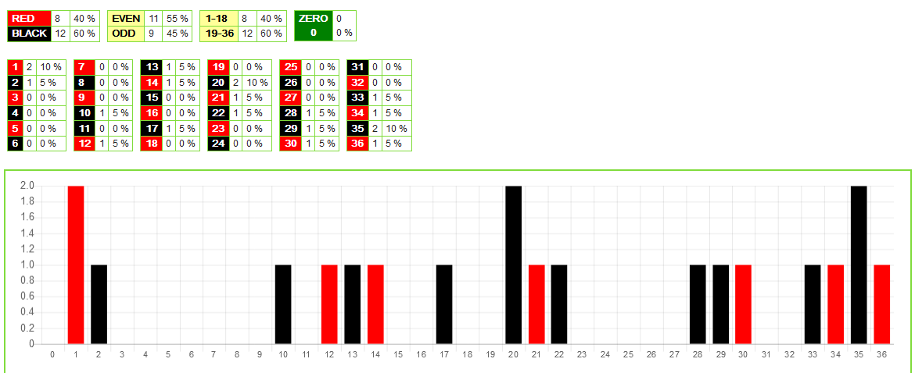
Ig! You can see none of your flat bet has hit after 20 spins.
But; I can tell you the 1st 10 spins had no repeat. So from a repeat point of view; they are late.
Now, as 10 spins no repeat, on average for the spins 11-20, we could have another 7 non-hits. As the graph shows, 3 numbers have repeated. But if for 40 spins, we expect to see 16 repeats, we should have had 4 repeats! So repeats are slow, but in the next 10 spins you could see the total for repeats is 8?
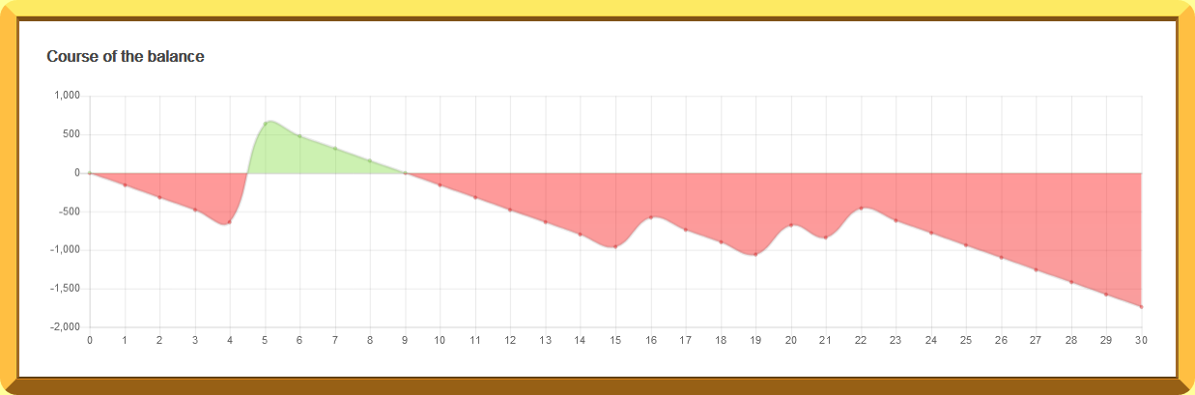
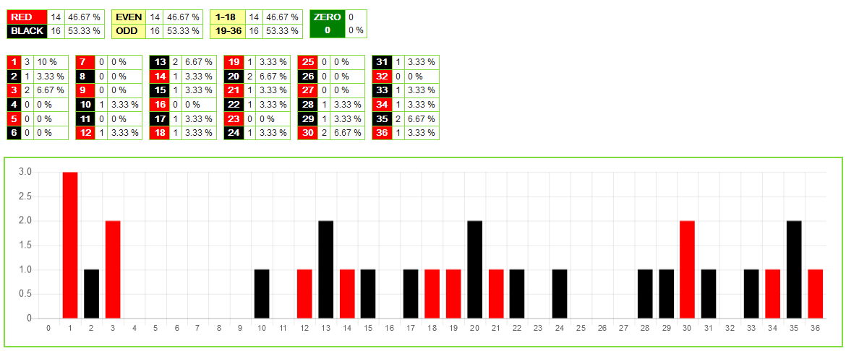
So; still no hit for your flat bet.
You can see 7 repeats! With 10 more spins to come. Too get to 16 repeats showing they have to pick up. You can see the made up law of the third by the General and his cronies that says 23/24 of the starting 37 will have hit by spin 37? These 30 spins have given 23 of the starting 37 non-hit already.

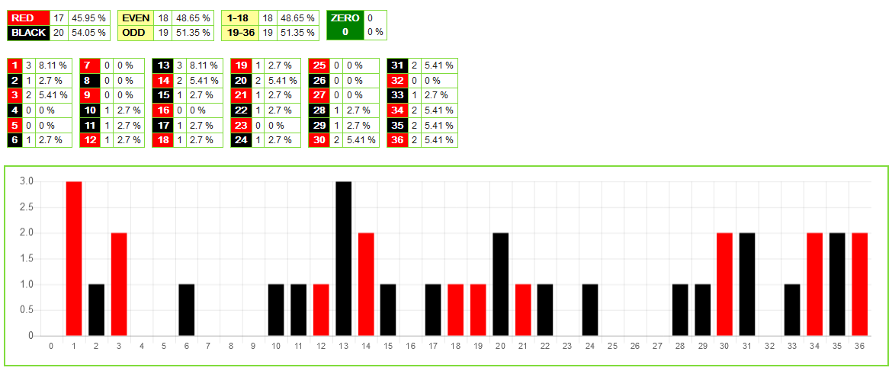
37th spin and 25 of the starting 37 have hit! So you have 12 repeats. With 3 more spins you won’t have 16 repeats.
Now as the 1st 10 spins ended 10/10, no repeat; we could see 25 of the starting non-hit, could have hit by spin 40, well they have already hit. Usual for the 30 spins, 11-40 the ratio is 15 non-hit and 15 repeats. So what will the next 3 spins give? How about 1 more non-hit and 2 repeats?
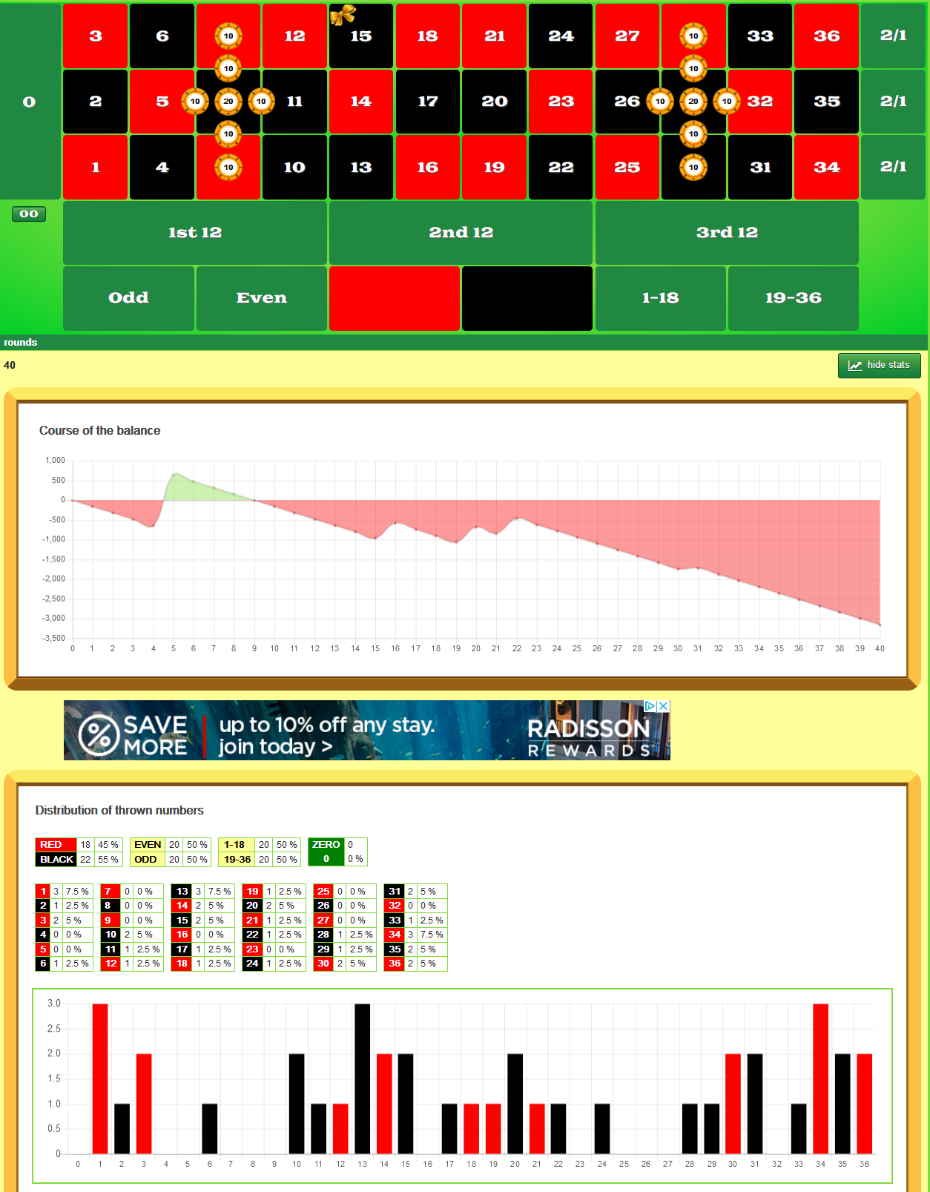
Well last 3 spins were all repeats. So the 15 non-hits on average in spins 11-40, showed.
So like in the topic; some analogy between roulette and river or wind, the weather forecasters use gazillions of models to predict the weather.
To get the average for spins 11-40; there have been thousands of models collected.
You can see I mirrored your flat bet and the mirrored section scored better.
Now this is no personal attack on you IG! It was to just see whether the average of 15 of the remaining non-hits would show over the 30; 1/37 spins.
Here is the breakdown of the 1/37; that gave the average of the 15 non-hits over spins 11-40.
You can see the TROT in blue; something the experts can’t see!
Now repeats for the Saint!
So you wait for 4; R1’s or till 20 spins have gone. In orange and blue you can see total is 50 units with return of 72 units.
You should reset as Turbo and Eddy say don’t bet too many numbers! You can see another R2 at spin 39; but you have 11 R1’s. Checkpoint box you see 7 non-hits by 20th; 13 non-hits by 30th and 15 non-hit by 40th.

