Free-roulette
You showed from 10 million trials the average to hit for the next non-hit. Your source for the data was different from mine. But the average’s are perfect.

Okay 24 hours and no one has looked at the non-hit time tables; in real roulette spins in the resources and downloads board. Your loss not mine.

Free-roulette if you opened the Generals file you could lift the 10330 spins. I’m not sure but think he posted them in Turbo, hoping too discredit Turbo, but as said you can get them from the file.

So what’s not to understand? Collecting the data shows the average for repeats is 1-3-5-7 & 30 over 60 spins.
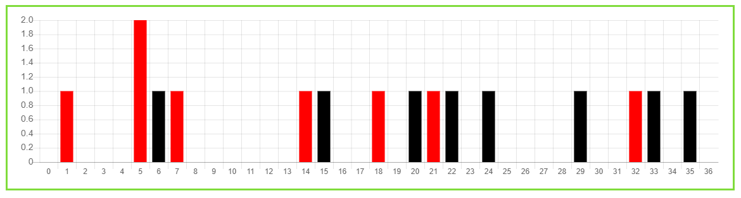
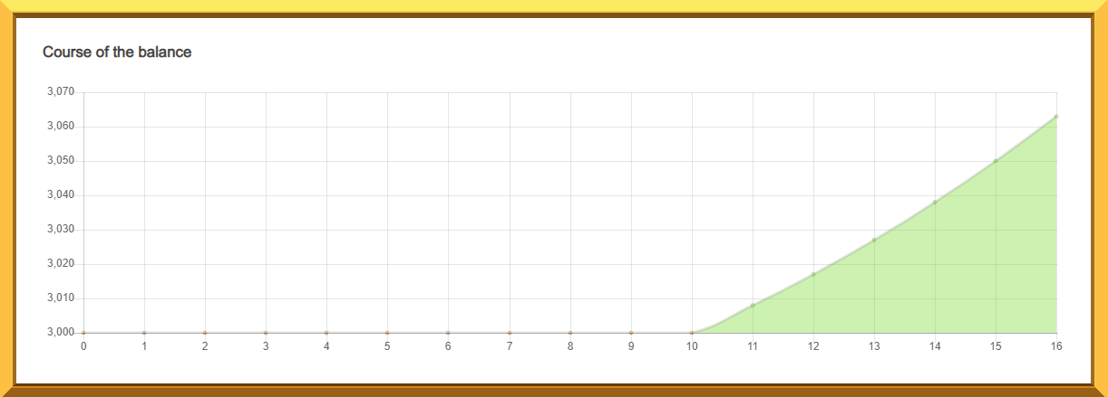

Here you see a good profit at spin 16. You can see 1 repeat has happened; obviously in spins 1-10 as last 6 are wins betting non-hits. If 4 repeats are expected in spins 1-20; why carry on as repeats are late. We could see another 3 repeats if the average is fair.
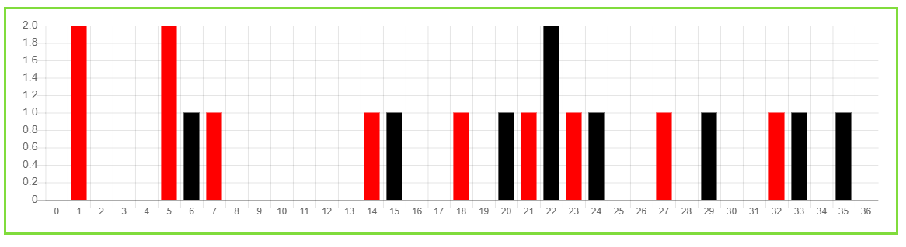
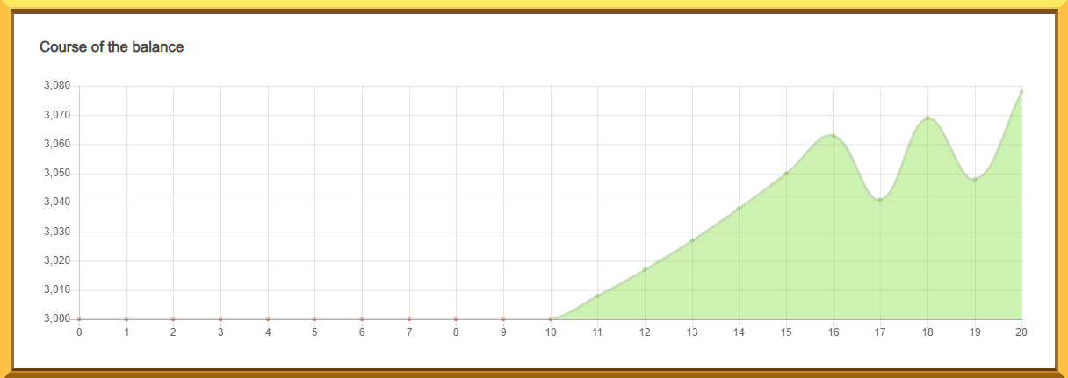

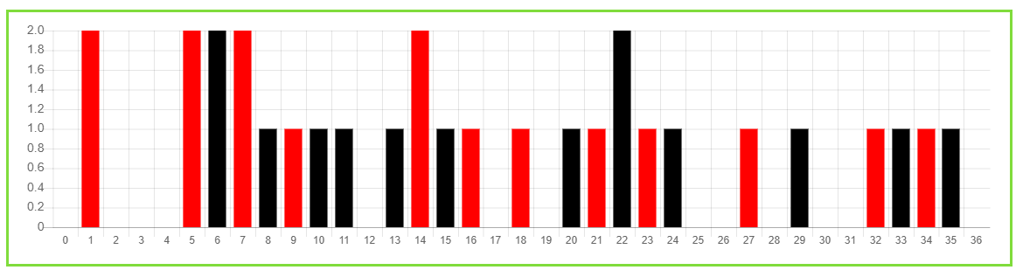
So if you carried on to 20th spin; you’ll see 3 repeats have happened. The average for the next non-hit of 2 spins up to the 19th non-hit from the starting 37, is fine. More profit.
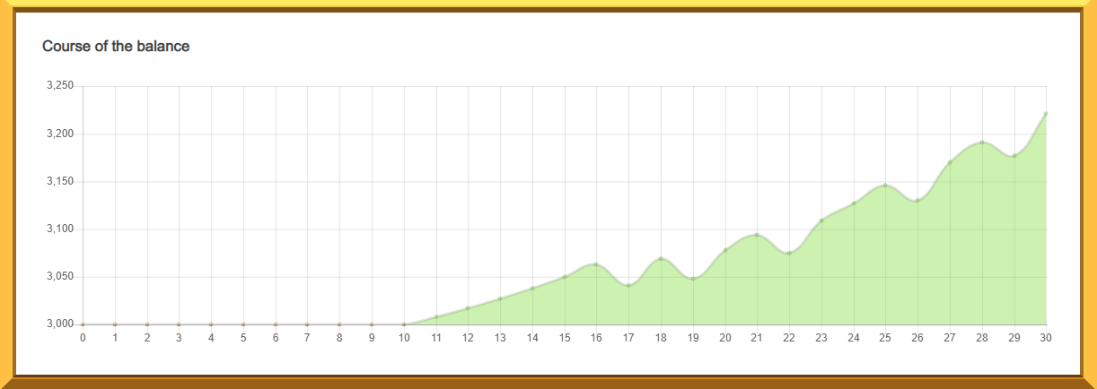
Now at 30 spins we can see more profit!
6 repeats; so repeats are late. We could or should have had 1-3-5; 9 repeats.
With 220 profit and repeats late and spins 31-40 usually having 7 repeats, would you carry on betting for non-hits; and 24 of the starting 37 have hit.

