Tonino
Saints best mate Turbo; said why bet 1x’s, they’ve only met expectation.
Then Turbo says bet straight away. Other experts say waiting is no good either.
So, bet straight away? Like Vaddi?
Okay, GUT would show how non-hit numbers show. From KTF; data shows repeats come over 60 spins, 1-3-5-7-30. Not bad 30 repeats and 30 of the starting 37 have hit.
Here you see new highs and stopped at spin 15, the last #19.
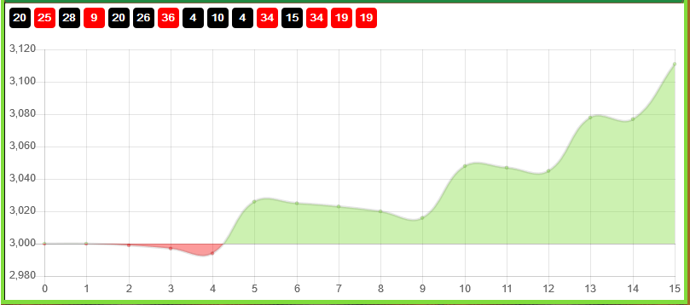
Can you see even thou I reset on a new high; the actual stream shows 4 repeats at 15 spins. What was to say the 5 remaining spins would not be all non-hit from the remaining starting 37?
The above was last session today.
Below the session before.
The reset at spin 37; the repeats were fair to the 1-3-5-7-30.
After spin 37, the reset we can see 13 consecutive non-hit of this starting 37. After the win another run of losing bets for repeats. There are numbers repeating, but not being bet. Reason I’m betting only the 4 hottest numbers.
Above you can see the spins from spin 37. Of these 58 spins, 31 of the starting 37 have hit.
As average for repeats is 1-3-5-7-30; would spins 59-60 have more chance of being repeat? But remember the experts will say it’s a 1/37 spin. If you think a repeat is more likely, where from, the 1x or the R1-2-3-4. The last non-hit was spin 55, #35, the non-hit average at this stage of the game for non-hit is 3 spins


