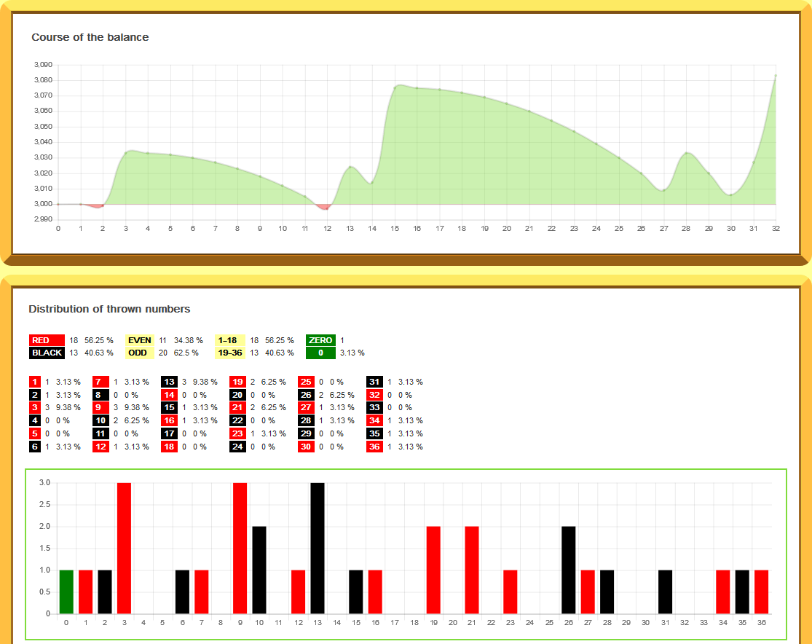
Mumbo; lets get in to Turbo’s time machine, and go back to the @ Turbo
Topic. So, raindrops? Above shows 32 spins. So, let’s lay 37 boxes out on the floor. If we use the 32 spins, we can see some of the boxes have more than one raindrop. 3 boxes have 3 drops, and others have 2 drops.
So, we won’t see Saint Steve’s 37/37; EVER
If you were to have bet for 37 spins re-betting every number, you’d have bet 703 units, but you would win as 1 of the 37 has to repeat.
So, Turbo said bet every spin; but you get the expectation part thrown in. Will you now only bet a number if its met expectation, yes because you want a repeat. Why bet a number that is cold?
Now you’re on the path of repeats. The next question is how to bet them? And, 1-2-3-4-5 progression is given. Even 1-5-25.
Let’s use 1-2-3-4-5; on the above. You can see win on spin 3. So, I reset. Free spin and start betting the raindrops again. As it’s a reset all 37 non-hit are in play again and 8 of the starting 37 hit; win on 9th spin, but profit is lower. Now increase the bet to 2 unit; and lose.
The last spin is #3. The win above was on #9 repeat. Remember we’ve increased #9 to 2 unit. Lost next bet, but the #9 repeats and a new high.
So, reset and all 37 are in play again. Next 12 spins are all non-hit and next spin we get the repeat#26. Increase the unit on #26 to 2unit. So, we increase the winning number to the prog and the double #3 has us a new high.
Here’s a question on the prog of 1-2-3-4-5. 2nd column is the 1-2-3-4-5. The #3 has hit 3 times. So, when win with 1-unit, next bet is 2. Win. Would you bet 3 unit next or bet 4 unit.
We want a slow prog as the 1-5-25 can use the bankroll quick. If we were playing the 32 spins as 1 game, we’d now have 3#’s with 25 units. And if you get a flat game where it keeps hitting the non-hit and then the 1x’s those 25 units are costing!
Remember we had 20 consecutive non-hits on the other post
Those 20 consecutives did make the 60 spins a hard game to win but a profit was gained. Those 60 spins are below.

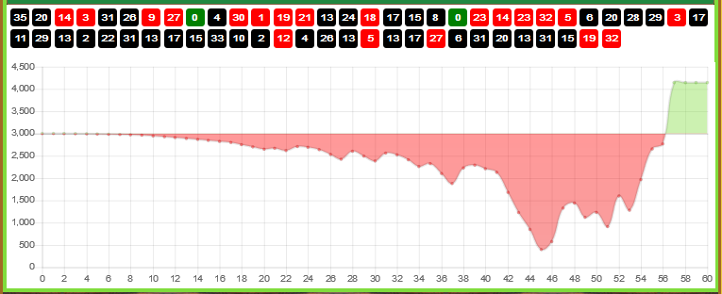

Mumbo; new game betting every spin using the 1-2-3-4-5; but bets go 1-2-4-7-11, etc:
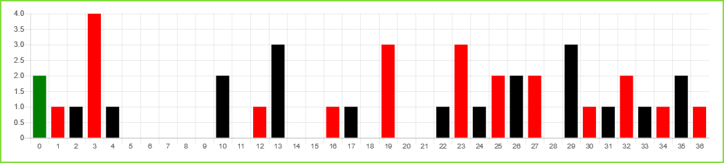
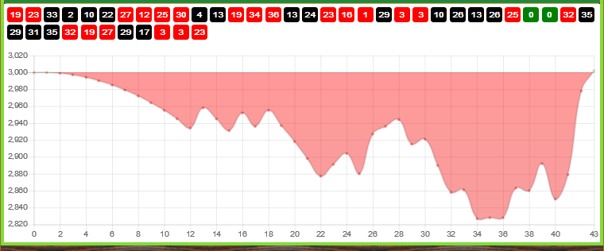
Again R-sim gives 12 consecutives, then the repeat. 3 repeats in 20 spins.
17 repeats in 43 spins. 16 usual for 40 spins. So, to get all 16 you have to bet every spin. If not in profit at 40 spins, repeats at 60 spins is usually 30, half.

A new game.
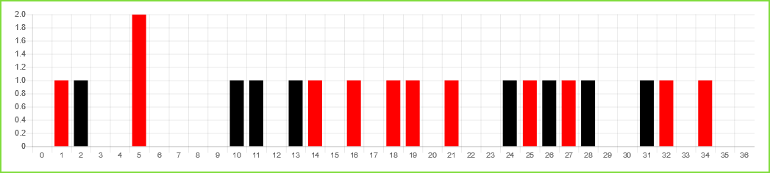
20 spins just 1 repeat.
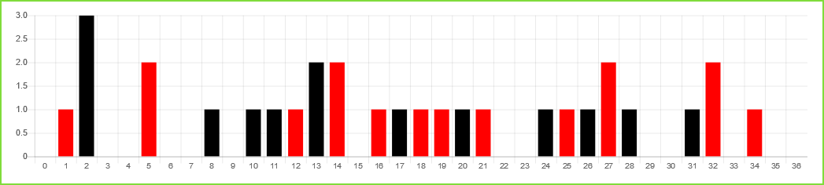
30 spins; 7 repeats, so 2 down on the expected 9 for 30 spins.
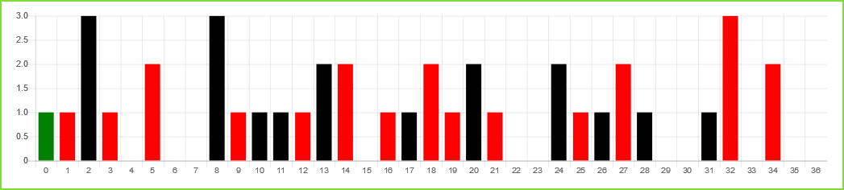
So, 40 rounds, 14 repeats, 2 down on the expected 16. Another 20 rounds to come; and at 60 spins the usual for repeats is 30, so will we get 16 repeats in the next 20 spins?
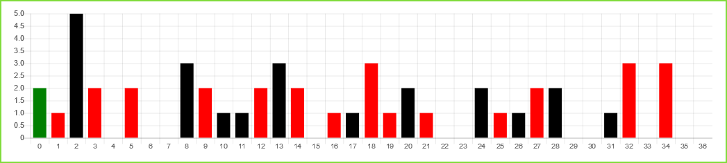
Now 50 spins/rounds and repeats stand at 24. But using the 1-2-3-4-5; but the actual betting units are 1-2-4-7-11; like shown above earlier, we now have a profit from betting repeats. Would 1-5-25 work?
Below the 50 spins.
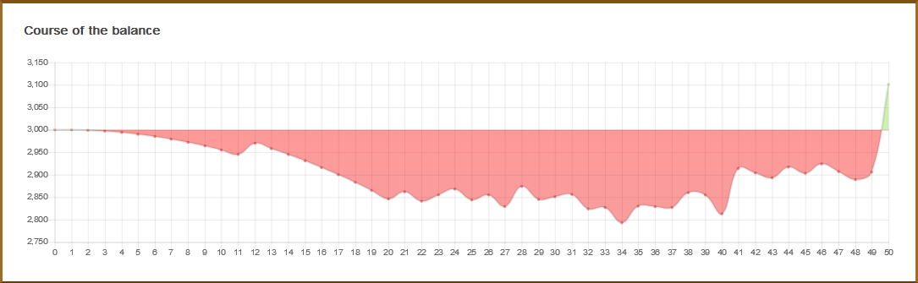
Now Mumbo would you reset or carry on with 11 non-hit and 10 1x’s; hoping the #’s 2-8-13-18-32-34 with the big units give you more profit?

A new game.
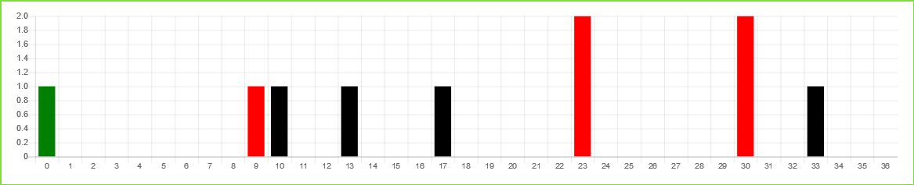
2 repeats in 10 rounds.
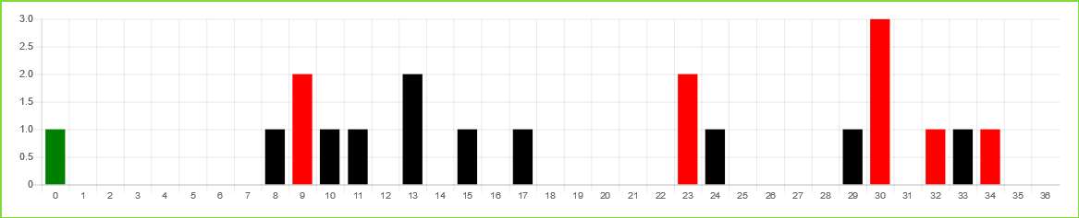
20 rounds 5 repeats; 1 more than the expected 4.
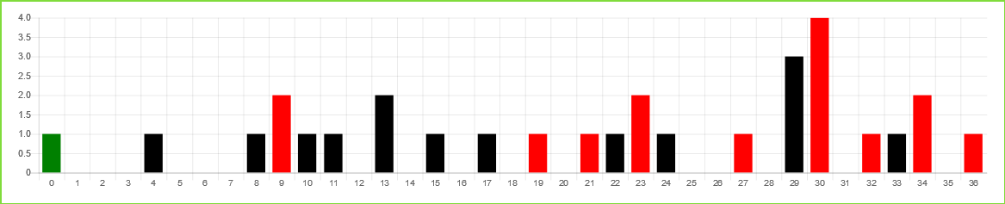
30 rounds repeats are perfect 9. The usual for repeats is 1-3-5-7-30
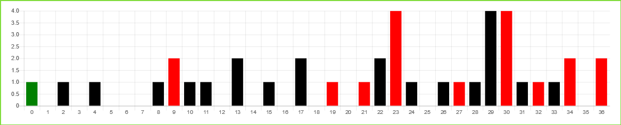
40 rounds;15 repeats, so, 1 down on the expected 16 for 40 rounds.
Now you have plenty of places to stop with profit.
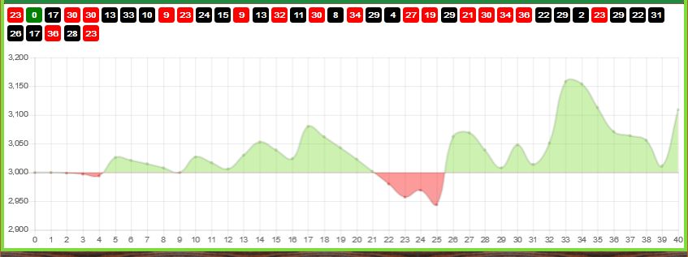
When to stop is your decision.

