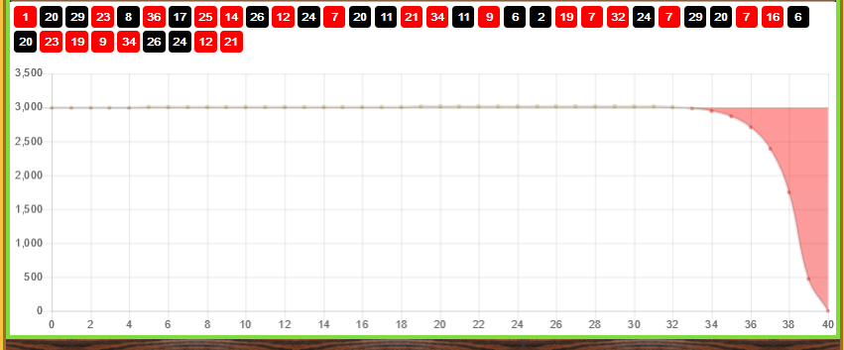
1 1 2 1 1 2 4 1 1 1 2 4 1 2 1 2 4 5 7 1 2 1 1 1 1 2 4 (1 2 4 5 7 8 10 11 13 14 16 17 19)
Hard to see, I had wins on spin 5 & 19. What I was trying for was looking for 4 losses in a row. Bracket, #20 would be #1, red lost. So, option 1 using columns 1 & 3 and zig-zagging back and forth down these 2 columns, took 13 spins. The order would be R-B-B-R-R-B-B-B-B-R-R-B-R-B; so, the opposite for 12 spins, then the order hit. As said, I lost track of where I was, but I should have won, even if the win would have been well down on starting BR.
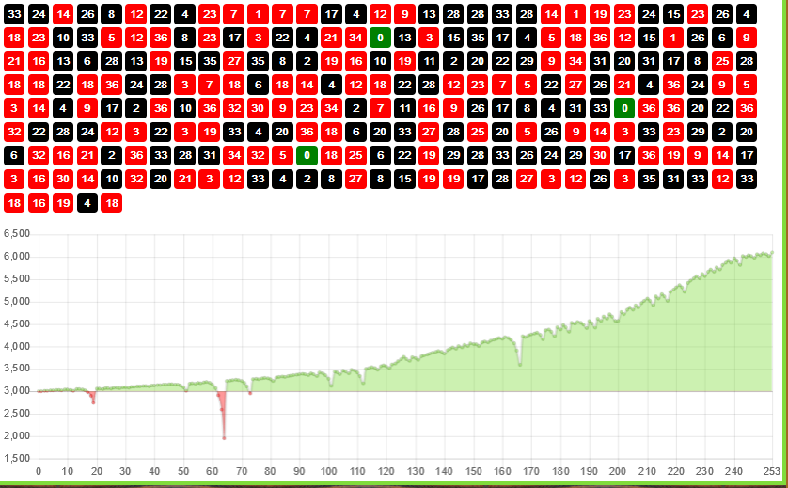
So, here won the lost 3000 and won the 100 I was trying for. But can you see, somehow, I avoided what happened in the losing game. See the blue connectors; if bet was for red by #1, you would lose or your bankroll would get you there. I’ll leave it here, you find away to avoid those losing spins of 12/13 or more.

