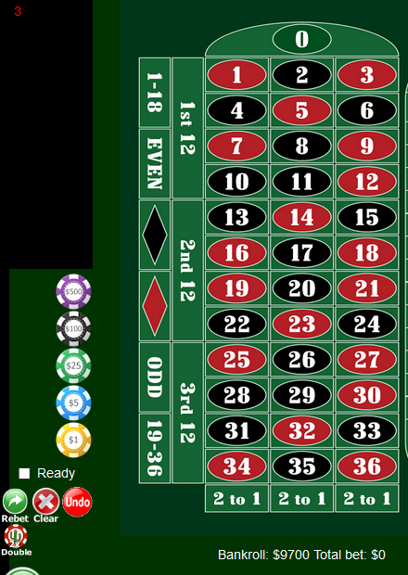
Come on & #3 is there BR is 9700
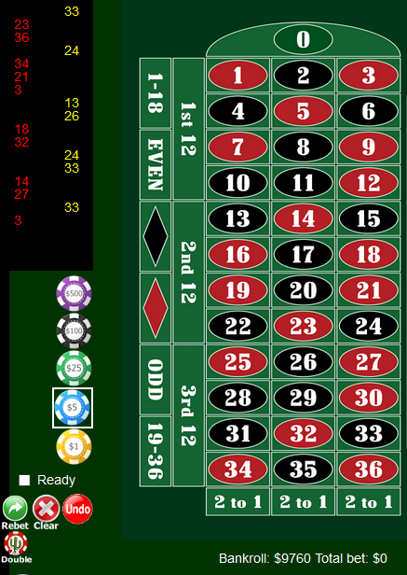
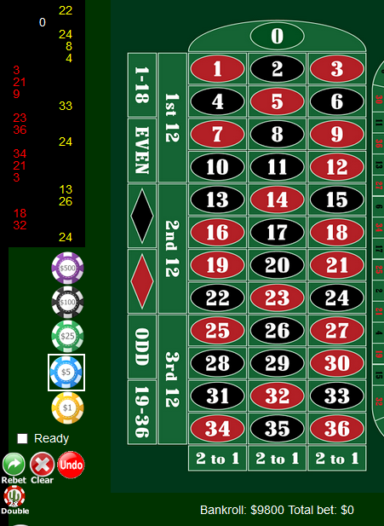
You see the spins +100 on the shite MPR; amazing it didn’t freeze or even spit out extra numbers.
It’s not using columns 2&3

