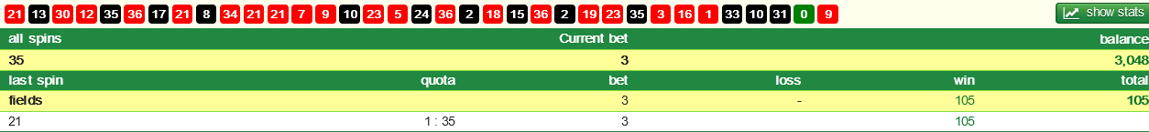
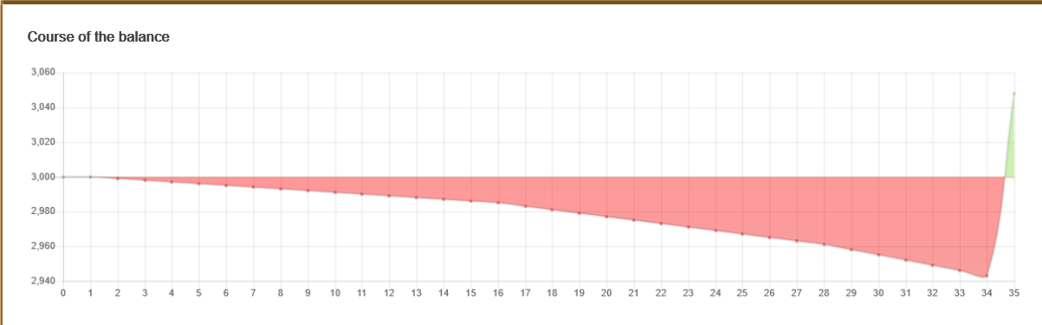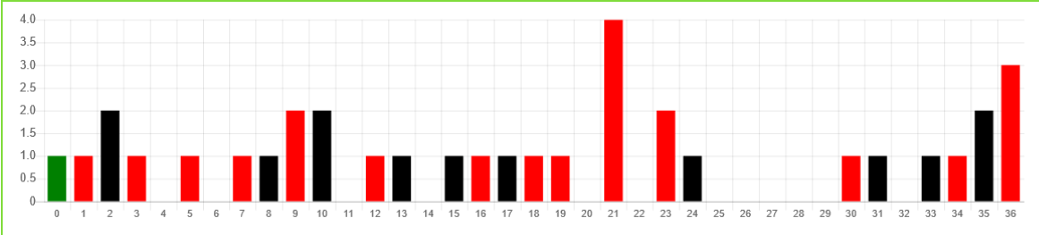

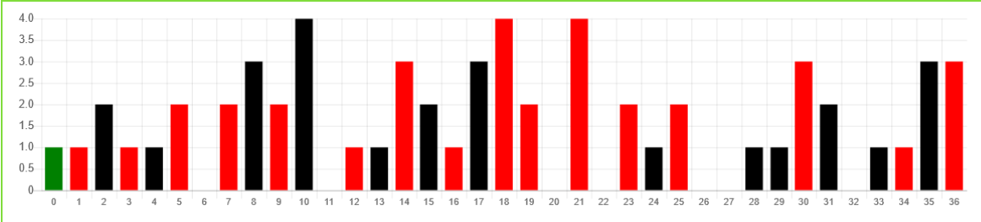
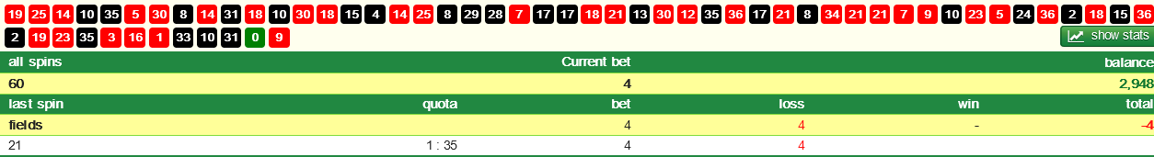
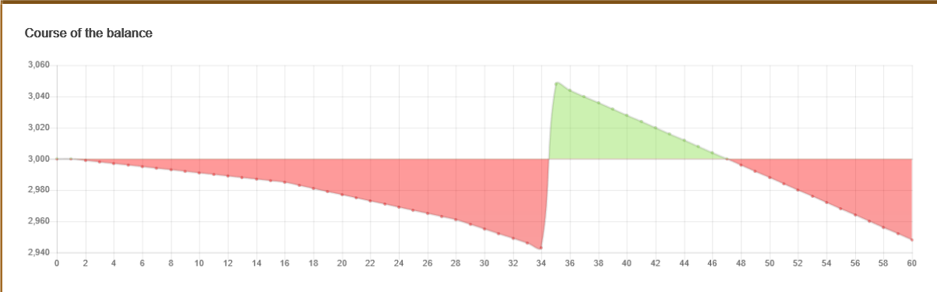

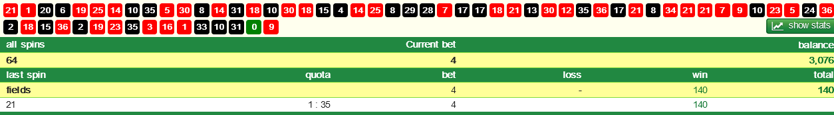
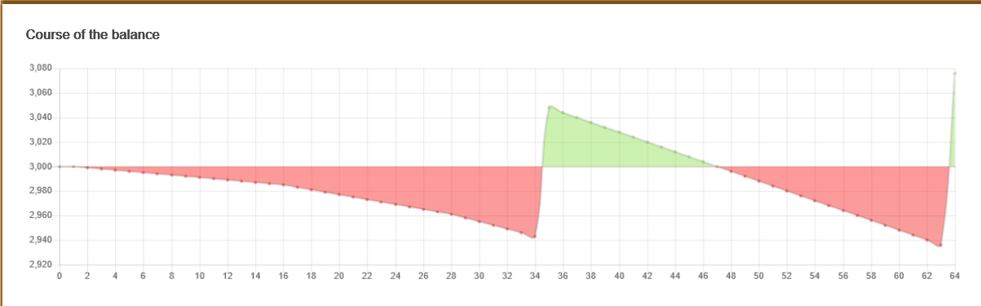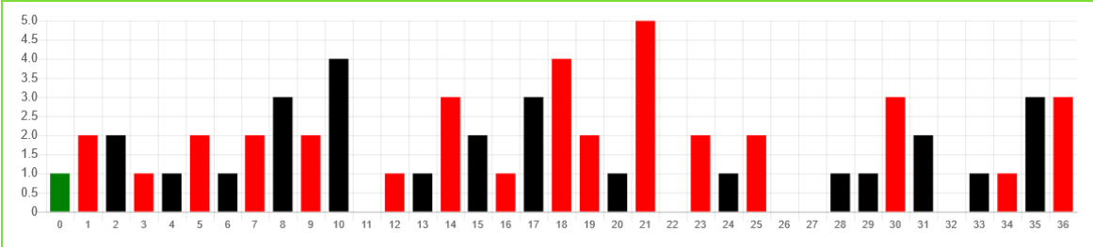

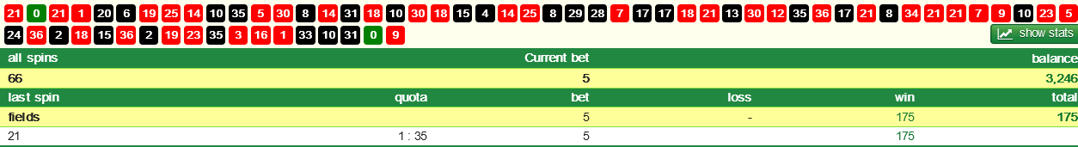
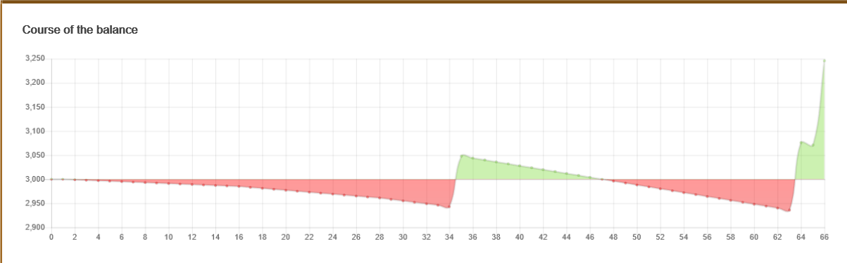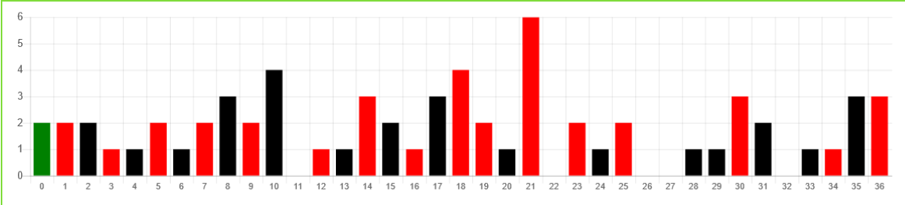

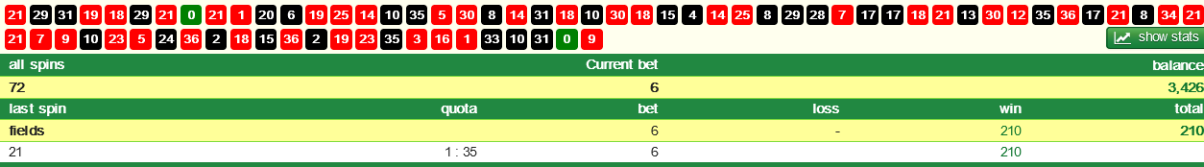
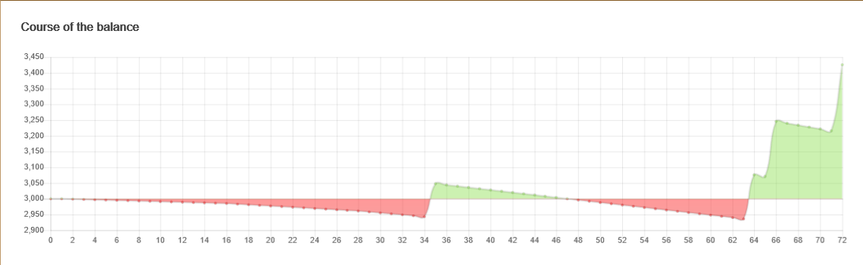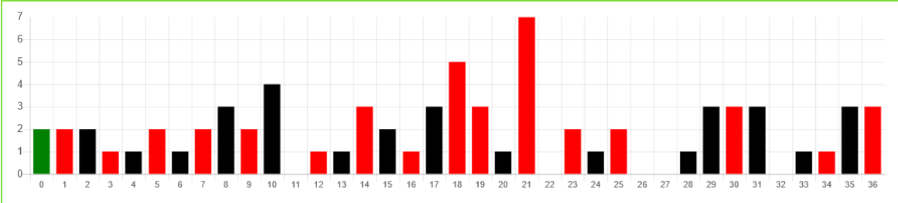

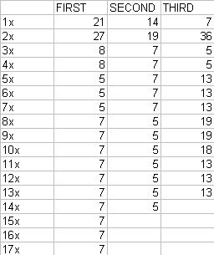
Clear and obvious results.
Perhaps it's time to stop calling "random" unpredictable.
But let's not tell the misfits or computer salesmen.

I mean.... "ok" ?
Here, I'll run off some fresh spins...
1x.....33
2x.....33
3x.....19
4x.....33
5x.....25
6x.....19
7x.....19
8x.....25
9x.....25
10x....25
11x....25
12x....25
13x....25
14x....25
15x....25
16x....25
17x....25
18x....25
19x....25
20x....25 *spin 437
So #25 isn't predictable ? 14 times out of 20 isn't predictable ?
(437/20)=21.85 So appearing 1 in 21.85 and NOT 1 in 37 and better yet 1 in 35 isn't predictable ?
This doesn't happen over and over with every test you run ?
Then there's nothing anyone can do - even the obvious isn't obvious enough I suppose.
But I tried lol.

The above 6 pages is betting just 1 number. If you are to replicate the above; 1x-20x and have a number like #25, you are going to have to bet the leader.
Is it wrong? If a number is to get hot, then it needs to keep repeating?
Would you never get a double? Only single leader all the time, like the 3x-4x-5x. Then a double and then; the fuck me look at that.
Will they always be late? Not in before 35 spins?

Or take the 1st profit, even if only 1 unit.
For GLOAT member General gormless he wants you to make a million, then leave. But he’ll spend years looking for a wobbly wheel.



