Two wheels method
The objective of this method is to avoid the wheel to make 3 any numbers in a row. To do that we need to play the numbers that prevent this situation.
The reason because it’s called “two wheels” is because every number is going to give us 2 numbers, as you can notice in the imagine below, every number has a positional pocket number, 32 has 1, 15 has 2, 19 has 3…….26 has 36. Just 2 exceptions, 0 and 4.
The tracking: this is the most important thing to do in this method, could be a little bit confusing at the beginning but then will be easier. To do the tracking I am using this wheel layout covered with a plastic protection, writing on it whit erasable marker.
Let say our first number is 5, so we’re going to mark number 5 as we see in the next figure, twice, first one is the number 5 on the wheel, and second one is the pocket number five, in this case is number 21 on the wheel:
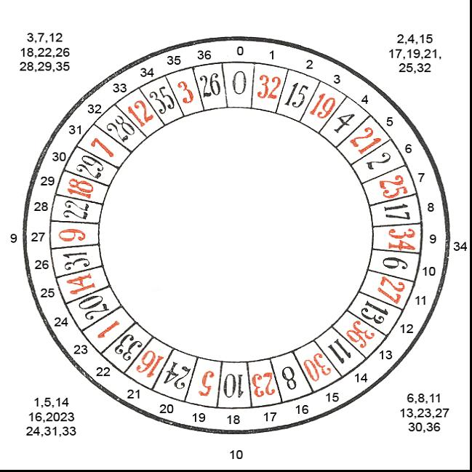
Notice that with the number 5 we are marking 2 numbers on the real wheel (5,21) and 2 numbers in the pocket wheel (5,19)
The second spin is number 17, our tracking should look like this:
Take a look at number 10 on the wheel, is the number that will make 3 in a row, and we need to avoid this, so we mark that number as one number to play. I’ll mark numbers to play with a blue arrow. Remember that every number is linked to a pocket, and they most played together, in this case is 10 and 18
With 17, we need to mark 17 and 23 in the real wheel, and 2 numbers in the pocket wheel (8,17)
So far we’ve got 2 numbers to bet (10,18) but we are not betting until we reach 3 numbers on the real wheel that could interrupt 3 numbers in a row.(we need to reach 3 blue arrows)
Let say next number is 34, this is our tracking should looks:
Because we’ve got 3 numbers on the real wheel, Is time to bet, so our first bet will be on numbers: 10,18,25,7,6
Why?, 10 is linked to 18, 25 is linked to 7 and 6 is linked to 10 and 10 is also one of the 3 blue arrows

At this point we’ve got 2 more numbers in the real wheel that could make 3 in a row: 25 and 6.

We mark 34 on the real wheel and 35 as well because it is linked to 34 in the pocket wheel
Next number is 34 again, when we get a repeater, we must mark it with the blue arrow as number we must bet (with his linked pocket number, in this case number 9). We need to mark 35 on the wheel as a repeater, because it is pocket 34
Now we’ve got 5 blue arrows, 5 numbers, our second bet will be: 10,18,25,7,6,34,9,35

If we hit one of the numbers we win and we are ready for a new tracking a new session, if we lose we are ready for a new tracking and a new session.

There is some important rules to follow:
- As I said before never bet if you don’t have at least 3 numbers in the real wheel that could interrupt 3 numbers in a row (3 arrows).
- All betting are flat
- We are going to bet until we reach 5 possible numbers in the wheel that could interrupt 3 in a row. To make it easier , we bet after we get at least 3 blue arrows and we stop after 5 blue arrows. Could happen that after 2 spins, there are just 2 numbers (2 blue arrows) so you can’t bet and need another spin, after the third spin we get a total of 4 numbers ( 4 blue arrows) and that will be our first bet. Let say we don’t win but with the spin number 4 we get a total of 6 numbers ( 6 blue arrows) that is going to be our second bet, and doesn’t matter what happen our session is end. Most of the time in average we bet just for 2 consecutive spins per session, sometimes could be 3
- When we lost we need to erase all tracked and start again from next spin, don’t use last spin to start a new session
- When we get a repeater, that number becomes a blue arrow, so has to be considerate as number to bet together with his linked number (pocket position)
That’s all for now, any question please post it in the forum, I would like to know your opinion about this system

cheers
Manuel Rosati
intrinseco@hotmail.com

