20 spins/ 2 repeats.
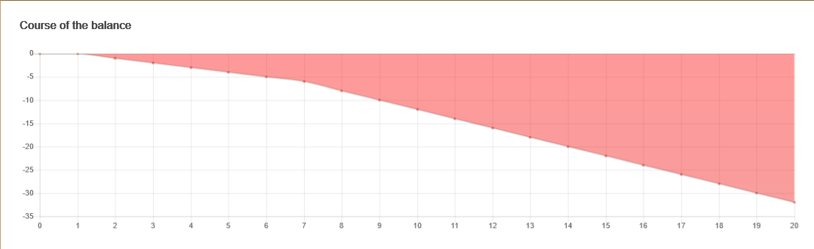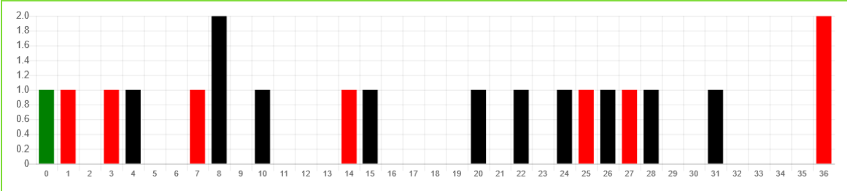
30 spins/ 8 repeats
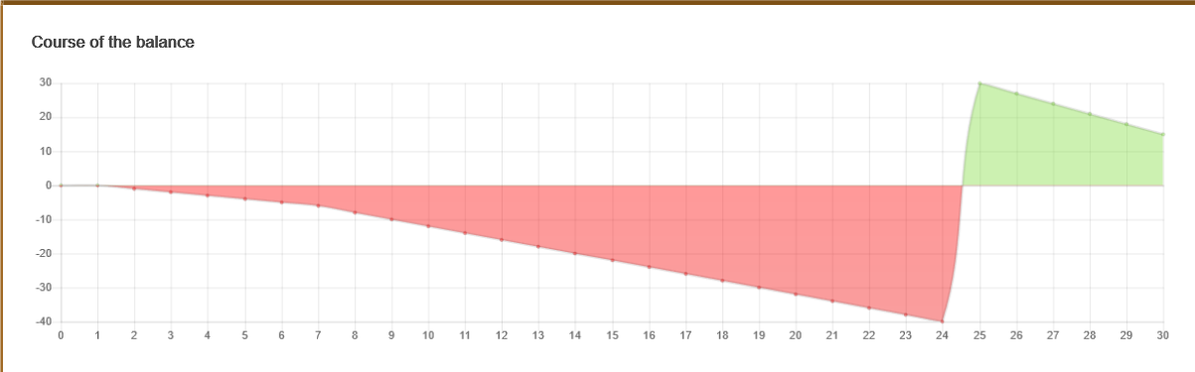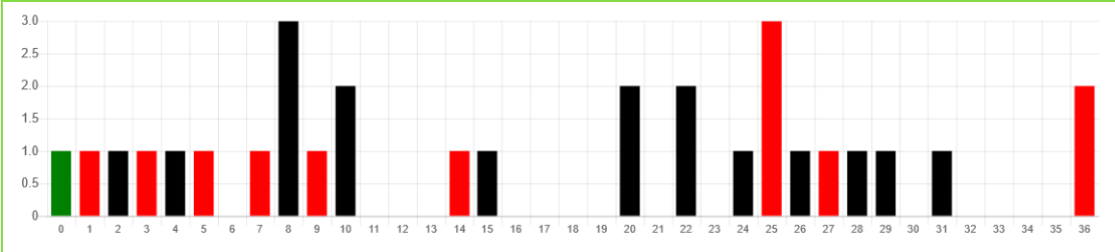

40 spins/16. Last 2 spins were repeat. Did they come 1-3-5-7 don’t know as not tracking every spin. But 16 repeats are the known.
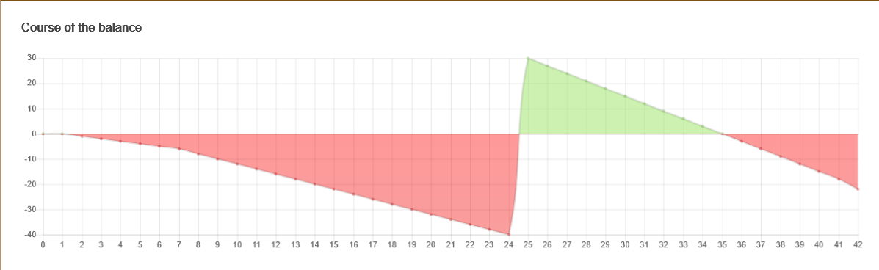
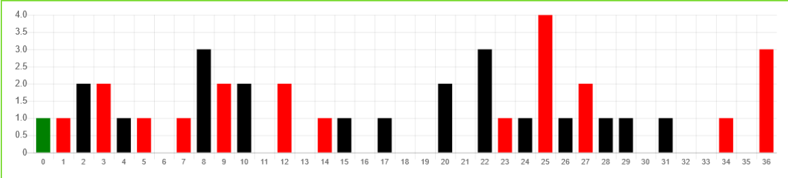

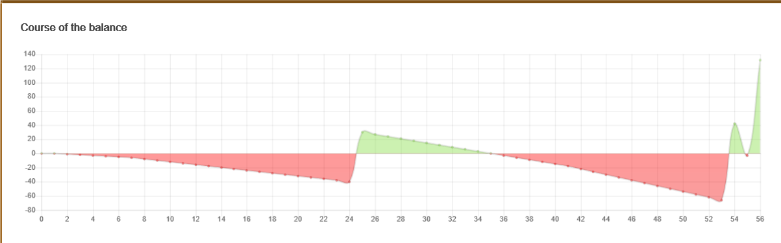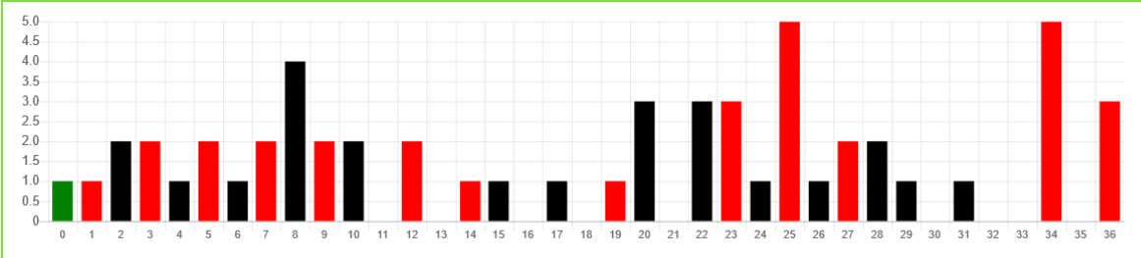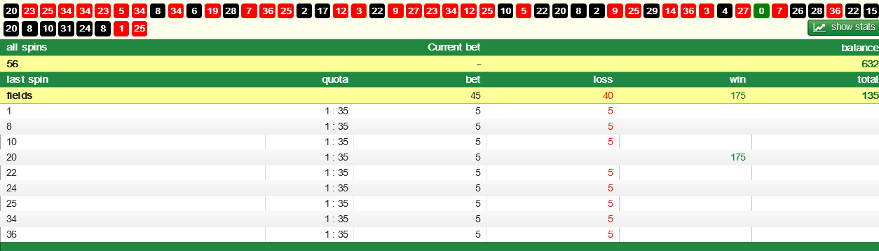
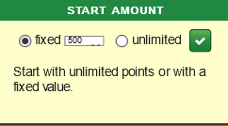
Mean; fixed bankroll of 500.
Started betting 1 number. You would not grasp the reason why.
Spin 54 contenders went from 1 number to 9 numbers.
9 numbers to choose from 28 numbers. 28 of the starting 37 have hit in 56 spins.
4 spins to 60 spins; average for non-hit at spin 60, is 30 non-hits.
Mean; think about 28 non-hits in 56 spins? It means there’s been 28 repeats.
You definitely are a member of GLOAT, Greatest Loser Of All Time.

