

Mister echo.

You can see at 10; +0, it means 1 repeat hit. At 20 you see, +3. Now as the game carries on, you’ll have had a thought; if this ends at 30; +3. Then you expect a block of 10 spins giving 5 more non-hit and 5 repeats. Last number is #18. 29 spins and we can see in the red box, we have 12 repeats. So, the 1-3-5=9; it’s already +3. Yes, it could go 13; making it +4. But really you would not bet the 20 remaining non-hits?

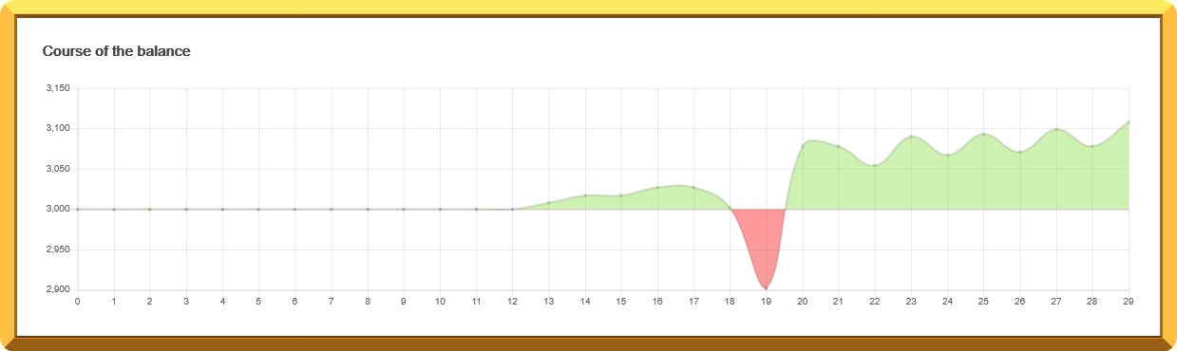

If it follows the graph then a loss is going to happen. But bravado favours the brave; I’ll bet those remaining 20 non-hits.



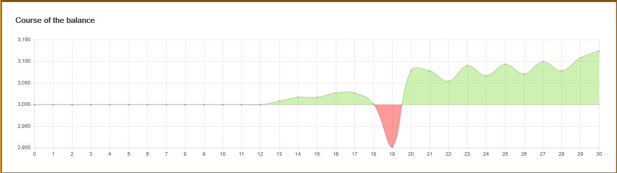 So EKO and General, I won. I suggest General you fuck off and do some wheel watching in stead of trying to understand the TROT